DNS SRV Record

🎯 What is a DNS SRV Record?
# Source: AI Source: Provided by: [Data Path: Persons Table -> ID Column: 1, Name_En Column: Motasem Essam] -> From: [ChatGPT] on [1/18/2026]
An SRV Record (Service Record) is a DNS record used to specify the location of servers for specific services in a domain. It tells clients which hostname and port to use for a particular service.
🧠 It’s like a specialized directory pointing to the servers that provide a given service (e.g., VoIP, messaging, or LDAP).

🔍 Key Details of SRV Record
# Source: AI Source: Provided by: [Data Path: Persons Table -> ID Column: 1, Name_En Column: Motasem Essam] -> From: [ChatGPT] on [1/18/2026]
- Purpose: Directs clients to the hostname and port number of servers for specific services.
- Format:
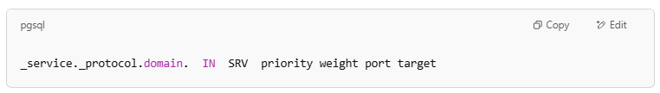
_service._protocol.domain. IN SRV priority weight port target

Where:
- _service = the symbolic name of the desired service (e.g., _sip, _ldap)
- _protocol = the transport protocol (usually _tcp or _udp)
- priority = preference of the server (lower means higher priority)
- weight = load balancing between servers with the same priority (higher means more preferred)
- port = port number where the service is running
- target = the hostname of the server providing the service

🌐 Example SRV Record
# Source: AI Source: Provided by: [Data Path: Persons Table -> ID Column: 1, Name_En Column: Motasem Essam] -> From: [ChatGPT] on [1/18/2026]
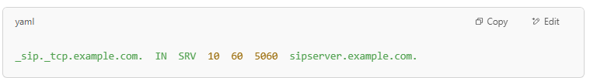
_sip._tcp.example.com. IN SRV 10 60 5060 sipserver.example.com.

This means:
- Service: SIP (Session Initiation Protocol)
- Protocol: TCP
- Priority: 10
- Weight: 60
- Port: 5060
- Server: sipserver.example.com

✅ Why Are SRV Records Useful?
# Source: AI Source: Provided by: [Data Path: Persons Table -> ID Column: 1, Name_En Column: Motasem Essam] -> From: [ChatGPT] on [1/18/2026]
- They allow service discovery and flexibility in specifying different servers, ports, and priorities.
- Commonly used for VoIP, XMPP (chat), Microsoft Exchange, and LDAP services.

Summary
# Source: AI Source: Provided by: [Data Path: Persons Table -> ID Column: 1, Name_En Column: Motasem Essam] -> From: [ChatGPT] on [1/18/2026]
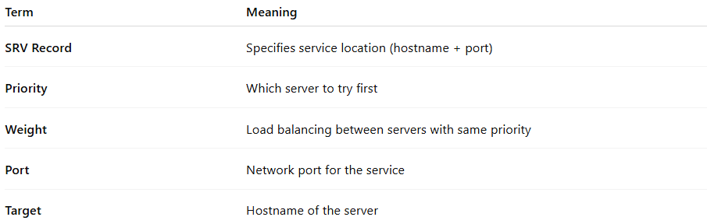
Term | Meaning
SRV Record | Specifies service location (hostname + port)
Priority | Which server to try first
Weight | Load balancing between servers with same priority
Port | Network port for the service
Target | Hostname of the server

